JECRC
JAIPUR
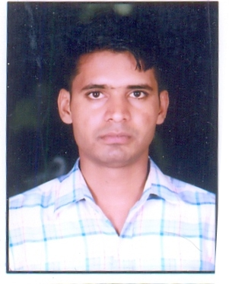
INDIVIDUAL Lab Instructor DATA SHEET
Name of the Lab Instructor | : | RAKESH KUMAR
Present Designation | : | LAB .TECH
Email Id: rakeshtalwara26@gmail.com
Contact Details: 9982630126

I. Particulars of Educational Qualification: (only completed)

Category | Name of the Degree | Specialization | Year of Passing | Name of the College | Name of the University
UG | B.A | ARTS | 2015 | PVT. | RAJASTHAN UNIVERSITY
DIPLOMA | I.T.I | ELECTRICIAN | 2013 | G.D.PVT. COLLEGE JAIPUR | BTER JODHPUR
DIPLOMA | DIPLOMA | ELECTRICAL | 2016 | JIPT COLLEGE JAIPUR | BTER JODHPUR [RAJ]

II. Academic Experience : 05

III. Industrial Experience : 02

IV. Awards/Achievements :

VI. Research/Specialization :

VII. Course Taught :

